TIMPANY SENIOR SECONDARY SCHOOL

COMPUTER SCIENCE PROJECT

COMPUTER SCIENCE

NAME: SARTHAK RUNTHALA
CLASS: XII SECTION: A
EXAM ROLL NO:

INDEX
S.NO | PARTICULARS | PAGE
 | TITLE OF THE PROJECT
 | BACKGROUND OF THE PROJECT
 | FUNCTIONS AND MODULES
 | FLOW OF THE PROJECT
 | USE OF TECHNOLOGY

FLIGHT RESERVATION
STUDENT DETAILS 2022-23

GROUP DETAILS 2022-23:
- SARTHAK RUNTHALA
- MIHIR JETTI
- CHERUKURI PAVAN KUMAR

BACKGROUND OF THE PROJECT

In today’s world, all the things have become computerized. We have developed a system called Flight Reservation using Python and MySQL. Initially the design is so simple that the user won’t find any difficulties while working on it and extracting the output of the required data.
Reservation means something that has been booked or been allotted by the person himself for his own purpose.
The main modules in this project are Passenger Details, Ticket Details, and Billing Details.
Passenger Details has all the features of the Passenger like Name, Gender and Age.
Ticket Details has all the features like Pilot_ ID, Flight number and Airline Name.
Billing details has all the features like Bill_ ID, Airline Name, Flight number and Fare.
Keeping such important details requires a lot of paper work. Hence, this software is useful in maintaining the database and makes the work much efficient and easier.

FUNCTIONS AND MODULES

MODULES

import mysql.connector:
By importing this package, we are able to establish the connection between SQL and Python.

FUNCTIONS
connect():
This function establishes connection between Python and MySQL.
cursor():
It is a special control structure that facilitates the row by row processing of records in the result set.
The syntax is:
<cursor object>=<connection object>.cursor ()
execute():
This function is used to execute the SQL query and retrieve records using Python.
The syntax is:
<cursor object>.execute(<sql query string>)
fetchall:
This function will return all the rows from the result set in the form of a tuple containing the records.
commit():
This function provides changes in the database physically.

FLOW OF THE PROJECT

- Our project is based on Flight Reservation. The project consists of 8 modules:

- CREATE TABLES
- SHOW TABLES
- INSERTION
- PASSENGER DETAILS
- TICKET DETAILS
- BILLING DETAILS
- DELETION
- EXIT

CODE
import mysql.connector as sql
con=sql.connect(host="localhost",user="root",passwd="1234",database="flight_reservation",charset="utf8")
def createtables():
cur=con.cursor()
cur.execute("create table passenger(P_ID int,Pname varchar(10),Page int,Gender varchar(5))")
cur.execute("create table ticketinfo(Airname varchar(10),Flightno int,Pilot_ID int)")
cur.execute("create table billinginfo(billid int,Airname varchar(10),Flightno int,fare int)")
if con.is_connected():
print("Tables creation success")

def menu():
cur=con.cursor()
ch='y'
while ch=='y' or ch=='Y':
print("1.createtables")
print("2.showtables")
print("3.insertion")
print("4.passenger details")
print("5.ticket details")
print("6.billing details")
print("7.modification")
print("8.deletion")
print("9.exit")
c=int(input("enter choice your choice"))
if(c==1):
createtables()
elif (c==2):
showtables()
elif (c==3):
insertion()
elif (c==4):
passengerdetails()
elif (c==5):
ticketdetails()
elif (c==6):
billingdetails()
elif (c==7):
modification()
elif (c==8):
deletion()
elif (c==9):
break
ch=input("enter your choice 'y' for yes and 'n' for no")

def showtables():
cur=con.cursor()
cur.execute("show tables")
for i in cur:
print(i)

def insertion():
cur=con.cursor()
ch='y'
while True:
if(ch=='y' or ch=='Y'):
print("*****Insertion******")
print("1.inspassenger")
print("2.insticket")
print("3.insbilling")
print("4.exit")
c=int(input("enter your choice"))
if(c==1):
inspassenger()
elif(c==2):
insticket()
elif(c==3):
insbilling()
elif(c==4):
menu()
ch=input("enter your choice 'y' for yes and 'n' for no")
con.commit()

def inspassenger():
cur=con.cursor()
c='y'
while True:
if (c=='y' or c=='Y'):
P_ID=int(input("enter passenger ID"))
Pname=input("enter passenger name")
Page=int(input("enter age"))
Pgender=input("enter gender")
cur.execute("insert into passengerinfo values({},'{}',{},'{}')".format(P_ID,Pname,Page,Pgender))
con.commit()
c=input("enter y for yes and n for no")
else:
insertion()

def insticket():
cur=con.cursor()
c='y'
while True:
if (c=='y' or c=='Y'):
Airname=input("enter airline name")
Flightno=int(input("enter flight number"))
Pilot_ID=int(input("enter PilotID"))
cur.execute("insert into ticketinfo values('{}',{},{})".format(Airname,Flightno,Pilot_ID))
con.commit()
c=input("enter y for yes and n for no")
else:
insertion()

def insbilling():
cur=con.cursor()
c='y'
while True:
if (c=='y' or c=='Y'):
billid=int(input("enter bill id"))
Airname=input("enter airline name")
Flightno=input("enter Flight number")
fare=int(input("enter the fare"))
cur.execute("insert into billinginfo values({},'{}',{},{})".format(billid,Airname,Flightno,fare))
con.commit()
c=input("enter y for yes and n for no")
else:
insertion()
def insertion():
cur=con.cursor()
ch='y'
while True:
if(ch=='y' or ch=='Y'):
print("*****Insertion******")
print("1.inspassenger")
print("2.insticket")
print("3.insbilling")
print("4.exit")
c=int(input("enter your choice"))
if(c==1):
inspassenger()
elif(c==2):
insticket()
elif(c==3):
insbilling()
elif(c==4):
menu()
ch=input("enter your choice 'y' for yes and 'n' for no")

def passengerdetails():
cur=con.cursor()
cur.execute("select * from passengerinfo")
data=cur.fetchall()
for i in data:
print(i[0],i[1],i[2],i[3])

def ticketdetails():
cur=con.cursor()
cur.execute("select * from ticketinfo")
data=cur.fetchall()
for i in data:
print(i[0],i[1],i[2])

def billingdetails():
cur=con.cursor()
cur.execute("select * from billinginfo")
data=cur.fetchall()
for i in data:
print(i[0],i[1],i[2],i[3])

def modification():
cur=con.cursor()
ch='y'
while ch=='y' or ch=='Y':
print("*****modification******")
print("1.passenger modification")
print("2.ticket modification")
print("3.billing modification")
print("4.exit")
c=int(input("enter your choice"))
if(c==1):
modpassenger()
elif(c==2):
modticket()
elif(c==3):
modbilling()
elif(c==4):
menu()
ch=input("enter your choice 'y' for yes and 'n' for no")

def modpassenger():
cur=con.cursor()
P_ID=int(input("enter P_ID for modification"))
Pname=input("enter Pname")
Page=int(input("enter age"))
cur.execute("update passengerinfo set Pname='{}',Page={} where P_ID={}".format(Pname,Page,P_ID))
con.commit()
cur.execute("select * from passengerinfo")
data=cur.fetchall()
for i in data:
print(i[0],i[1],i[2],i[3])

def modticket():
cur=con.cursor()
Airname=input("enter airname for modification")
Flightno=int(input("enter flightno"))
Pilot_ID=int(input("enter PilotID"))
cur.execute("update ticketinfo set Pilot_ID={},Flightno={} where Airname='{}'".format(Pilot_ID,Flightno,Airname))
con.commit()
cur.execute("select * from ticketinfo")
data=cur.fetchall()
for i in data:
print(i[0],i[1],i[2],i[3])

def modbilling():
cur=con.cursor()
billid=int(input("enter billid for modification"))
Airname=input("enter Airname")
Flightno=int(input("enter Flightno"))
fare=int(input("enter fare"))
cur.execute("update billinginfo set billid={},Airname='{}',Flightno={} where fare={}".format(billid,Airname,Flightno,fare))
con.commit()
cur.execute("select * from billinginfo")
data=cur.fetchall()
for i in data:
print(i[0],i[1],i[2],i[3])

def deletion():
cur=con.cursor()
ch='y'
while ch=='y' or ch=='Y':
print("*****Deletion******")
print("1.passenger deletion")
print("2.ticket deletion")
print("3.billing deletion")
print("4.exit")
c=int(input("enter your choice"))
if(c==1):
delpassenger()
elif(c==2):
delticket()
elif(c==3):
delbilling()
elif(c==4):
menu()
ch=input("enter your choice 'y' for yes and 'n' for no")

def delpassenger():
cur=con.cursor()
P_ID=int(input("enter P_ID for deletion"))
cur.execute("delete from passengerinfo where P_ID={}".format(P_ID))
con.commit()
cur.execute("select * from passengerinfo")
data=cur.fetchall()
for i in data:
print(i[0],i[1],i[2],i[3])

def delticket():
cur=con.cursor()
Airname=input("enter Airname for deletion")
cur.execute("delete from ticketinfo where Airname='{}'".format(Airname))
con.commit()
cur.execute("select * from ticketinfo")
data=cur.fetchall()
for i in dat7a:
print(i[0],i[1],i[2])

def delbilling():
cur=con.cursor()
billid=int(input("enter billid for deletion"))
cur.execute("delete from billinginfo where billid={}".format(billid))
con.commit()
cur.execute("select * from billinginfo")
data=cur.fetchall()
for i in data:
print(i[0],i[1],i[2],i[3])

menu()

OUTPUTS

OUTPUTS FROM PYTHON:

MENU:

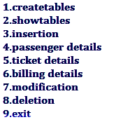
SHOW TABLES:

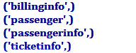
INSERTION:
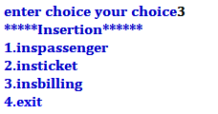
INSERTION OF PASSENGER:
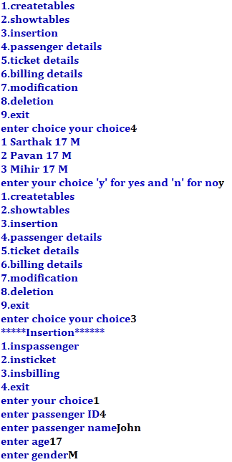
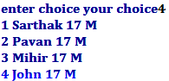

INSERTION OF TICKET DETAILS:
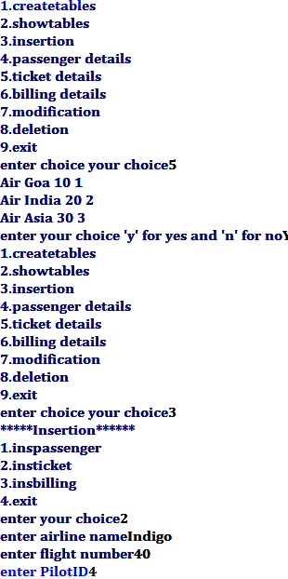


INSERTION OF BILLING DETAILS:
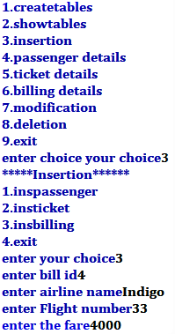
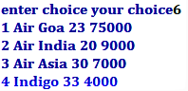

PASSENGER DETAILS:



TICKET DETAILS:



BILLING DETAILS:



MODIFICATION:
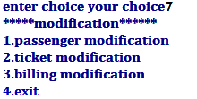
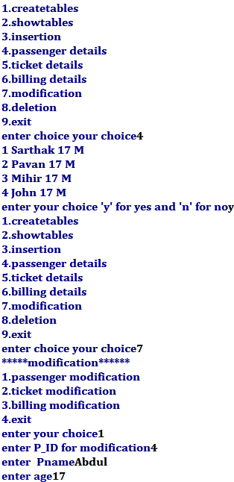
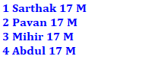

MODIFICATION OF BILLING:
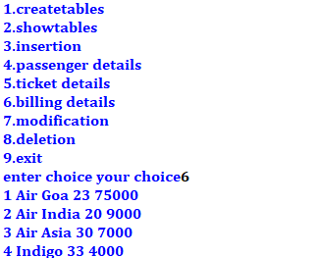
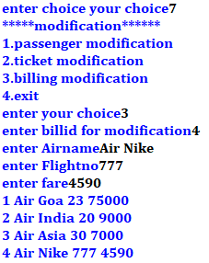

DELETION:
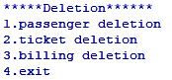
DELETION OF PASSENGER:
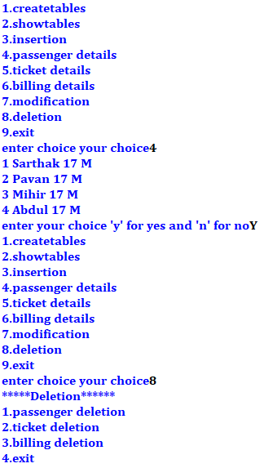
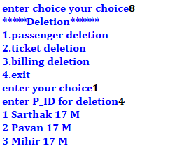
DELETION OF TICKET:

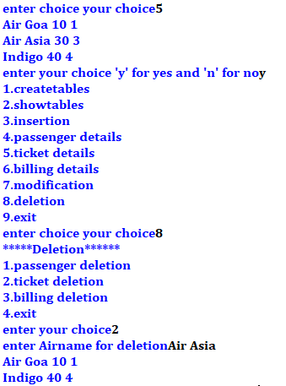

DELETION OF BILLING:

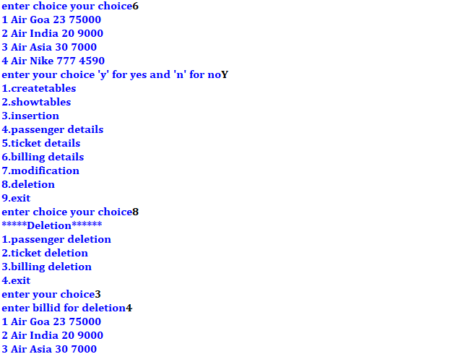

OUTPUTS FROM MySQL:

SHOW TABLES:
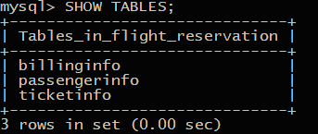
PASSENGER INFO (DESCRIPTION):
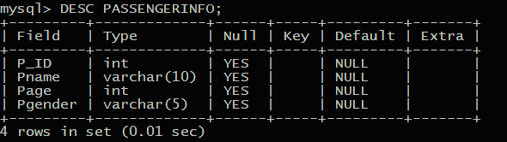

PASSSENGER INFO DETAILS:
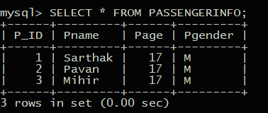
TICKET INFO (DESCRIPTION):
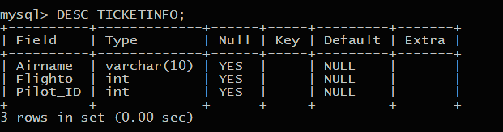
TICKET INFO DETAILS:
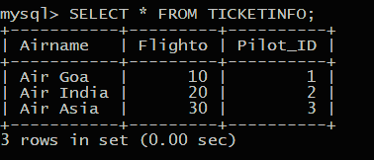

BILLING INFO (DESCRIPTION):
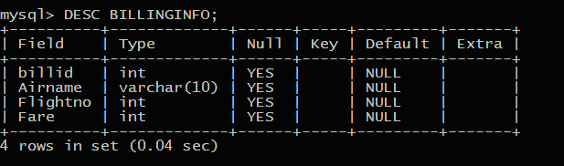
BILLING INFO DETAILS:
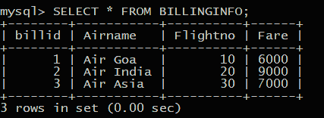

USE OF TECHNOLOGY



- What is MySQL?

MySQL is a relational DBMS that can run virtually on all platforms, including Linux, UNIX, and Windows. Popular for web-based applications and online publishing, MySQL is a part of open-source enterprise stack LAMP(Linux, Apache, MySQL, PHP).
MySQL is a freely available open source RDBMS that uses Structured Query Language(SQL). It is download-able from the site www.mysql.org MySQL is fast, reliable, scalable alternative to many of the commercial RDBMs available today. MySQL provides you with a rich set of features that support a secure environment for storing and maintaining data.
MySQL was created and supported by MySQL AB, a company based in Sweden. This company is now a subsidiary of SUN Microsystems which holds the copyright of most of the codebase. On April 12th, 2009 Oracle Corp which develops and sells the proprietary Oracle database, announced a deal to acquire Sun Microsystems.
SQL provides many different types of commands used for different purposes. SQL commands can be divided into following categories:

- Data Definition Language (DDL)
- Data Manipulation Language (DML)

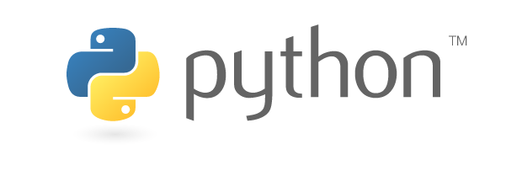
- WHAT IS PYTHON?
Python is an interpreted, object-oriented, high-level programming language with dynamic semantics. Its high-level built in data structures, combined with dynamic typing and dynamic binding , make it very attractive for Rapid Application Development, as well as for use as a scripting or glue language to connect existing components together. Python's simple, easy to learn syntax emphasizes readability and therefore reduces the cost of program maintenance. Python supports modules and packages, which encourages program modularity and code reuse. The Python interpreter and the extensive standard library are available in source or binary form without charge for all major platforms, and can be freely distributed.
Often, programmers fall in love with Python because of the increased productivity it provides. Since there is no compilation step, the edit-test-debug cycle is incredibly fast. Debugging Python programs is easy: a bug or bad input will never cause a segmentation fault. Instead, when the interpreter discovers an error, it raises an exception. When the program doesn't catch the exception, the interpreter prints a stack trace. A source level debugger allows inspection of local and global variables, evaluation of arbitrary expressions, setting breakpoints, stepping through the code a line at a time, and so on. The debugger is written in Python itself, testifying to Python's introspective power. On the other hand, often the quickest way to debug a program is to add a few print statements to the source: the fast edit-test-debug cycle makes this simple approach very effective.

ACKNOWLEDGEMENT

I would like to acknowledge all those without whom this project would not have been successful. Firstly, I would like to thank our Principal Mam, Mrs. Christobel Stevenson and our Computer Science Teacher Mrs Shanti Kiran who guided me throughout the project and gave her immense support. They made us understand how to successfully complete this project and without them, the project would not have been complete.
This project has been a source to learn and bring our theoretical knowledge to the real-life world. So, I would really acknowledge their help and guidance for this project.
I would also like to thank my parents who have always been there whenever needed.
Once again, thanks to everyone for making this project successful.

BIBLIOGRAPHY

- www.google.com
- www.python.org.in
- www.mysql.org.in
- www.tutorialaiscsip.com
- www.idealsoftware.com

CONFIGURATION

SYSTEM:

OS – Windows 10 Professional 64-Bit

Language: English

System Manufacture: Gigabyte Technology Co., Ltd.

Processor: 11th Gen Intel (R) Core i5-3220CPU 2.40GHz

Memory: 2048 MB RAM

